# Overview

The Global Terrorism data set contains data of terrorist activity around the world from 1990 to 2016. The Global Terrorism workbook consists of two primary dashboards:

1. The global terrorism dashboard consists of an overview of terrorist attacks around the world. The visuals inform the user on broad metrics such as: How many terrorist attacks happen in each country? What was the attack method and target? How many fatalities occurred within these attacks? What cities and states were impacted?
2. The target group dashboard consists of data regarding specific terrorist groups. The target group dashboard tells us things such as: What are the most popular attack methods and target types by each terrorist group? How many terrorist attacks has each group claimed? What region is each group most active in? How has terrorist group activity changed throughout the years?

# Global Terrorism Analysis Dashboard

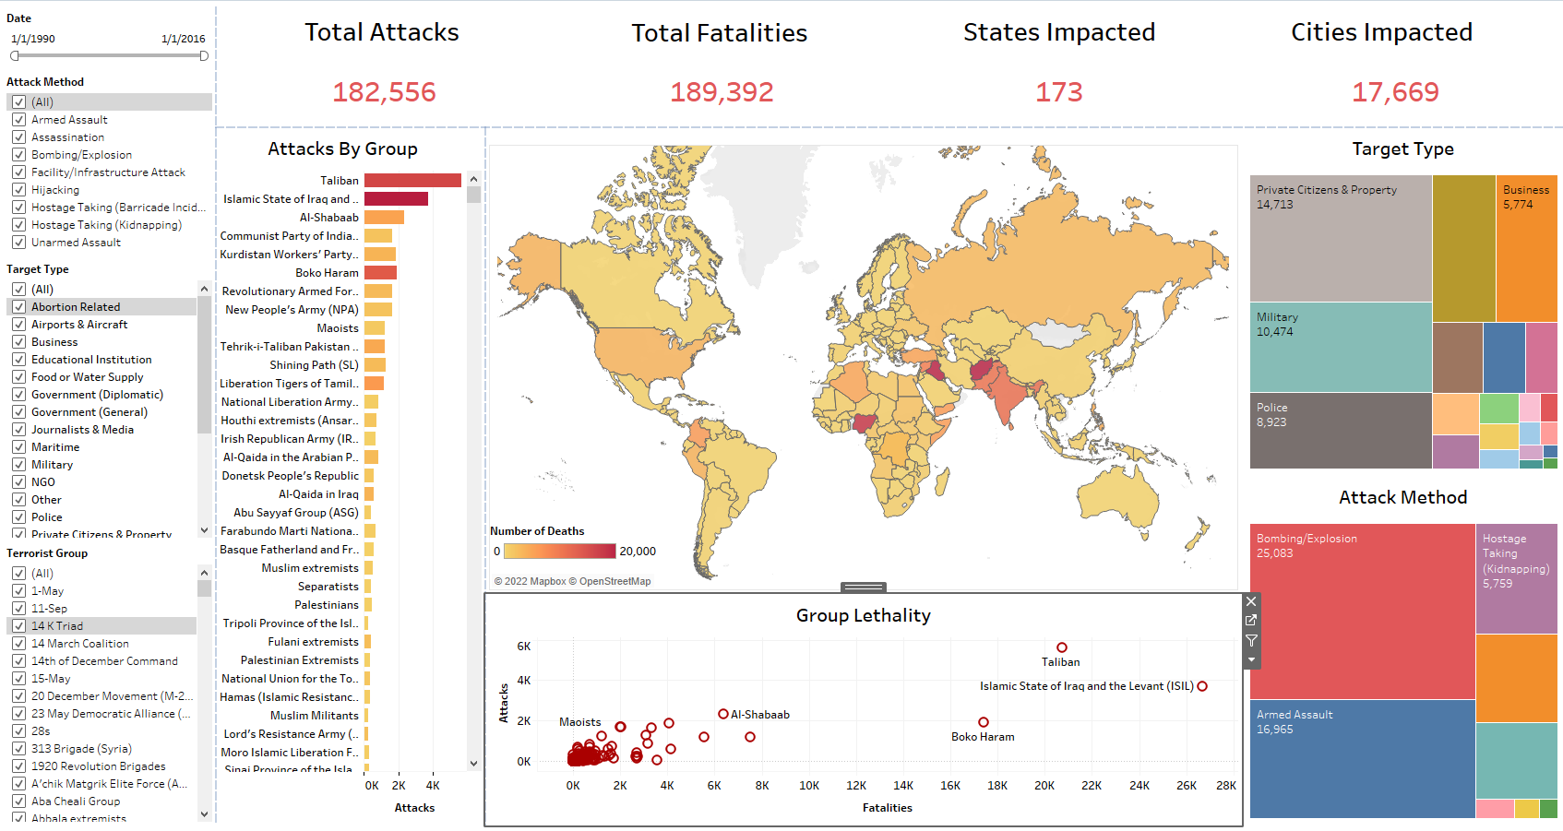

Attached above is an overview of the Global Terrorism Dashboard. The main features include a global map, target type tree map, attack method tree map, attack by terrorist group bar chart, and a terrorist group lethality scatter chart.

The dashboard also contains cards at the top of the dashboard displaying the total number of attacks, fatalities, states impacted, and cities impacted.

Filters are provided on the left-hand side of the dashboard. These filters include the date, attack method, target type, and terrorist group. The date filter allows for users to filter by a specific date or time frame starting from 1/1/1990 through 1/1/2016. The attack method filter allows for the user to filter by one, multiple, or all attack methods such as armed assault, bombing/explosion, etc. The target type filter allows for a user to filter by one, multiple, or all target types such as airports/aircrafts, business, food/water supply, etc. The terrorist group filter allows for a user to filter by one, multiple, or all terrorist groups within the data set.

When a user hovers over a country in the map, a tool tip will appear displaying the country name and number of fatalities.

When a user clicks on a country, the surrounding charts and cards will change to filter to data regarding that country only.

For example, if I click on Iraq, the surrounding charts inform me that the greatest number of attacks have been carried out by the Al-Qaida and ISIL. The most lethal group in Iraq has been ISIL. These terrorist groups target private citizens and property the most with bombing and explosions being the most used attack method. The cards above inform me that the total number of attacks are 13,923 attacks with 29,166 fatalities between the years 1990 – 2016.

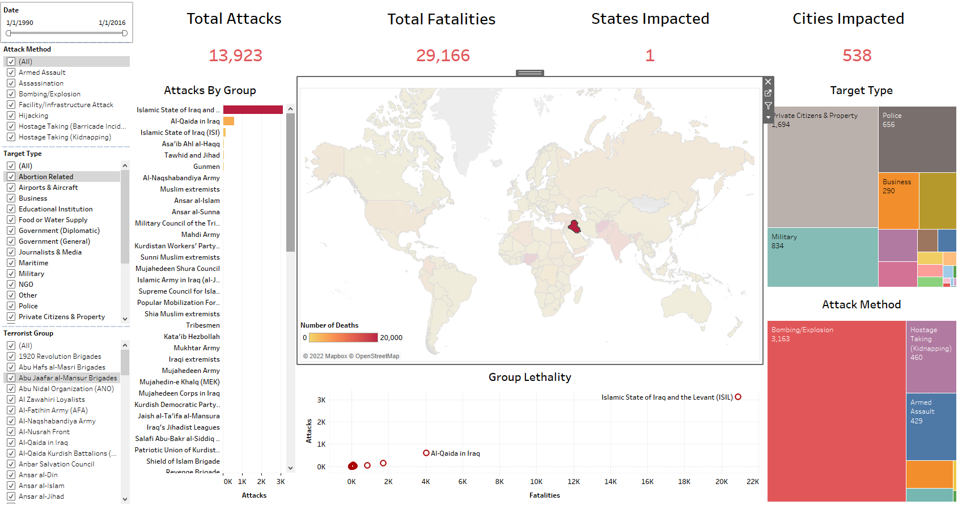

# Target Group Analysis Dashboard

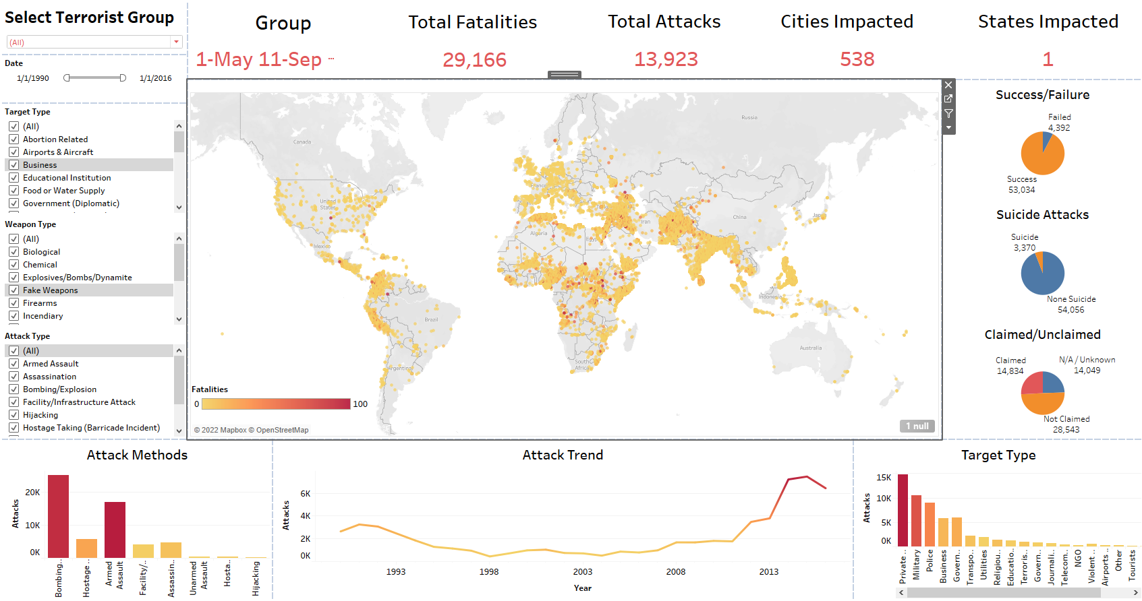

The visual above shows an overview of the target group analysis dashboard. The dashboards main features include a global map, bar chart including attack methods, bar chart including target types, an attack tend chart, and pie charts including success/failure rate, suicide/non-suicide attack, and claimed/unclaimed attacks.

The dashboard also contains cards that show total fatalities, total attacks, cities impacted, states impacted, and terrorist group.

The dashboard contains filters on the left hand-side to interact with the dashboard. These filters include terrorist group, date, target type, weapon type, and attack method. The terrorist group filter allows for a user to filter by one, multiple, or all terrorist groups within the data set. The date filter allows for users to filter by a specific date or time frame starting from 1/1/1990 through 1/1/2016. The target type filter allows for a user to filter by one, multiple, or all target types such as airports/aircrafts, business, food/water supply, etc. The weapon type filter allows for users to filter by one, multiple, or all weapon types used such as biological/chemical/firearms etc. The attack method filter allows for the user to filter by one, multiple, or all attack methods such as armed assault, bombing/explosion etc.

The points on the map show which attacks were the most deadly based on color. The darker the point, the more fatalities occurred. When a user hovers over a point on the map, a tool tip will appear containing information on the terrorist group, location, motive, summary of the attack, and fatalities that occurred.

When a user chooses a terrorist group through the filter, the surrounding charts will change to demonstrate information based on that terrorist group alone. For example, when I click on ISIL, the map changes to show only attacks carried out by ISIL around the world. The cards show that ISIL has performed 12,326 attacks with 26,672 fatalities total. The cards also show that ISIL attacks have been carried out in 20 states with 648 cities impacted. The pie charts show that ISIL has mostly successful attacks with 3,418 successful attacks and only 296 failed. Most attacks were non-suicide missions. The pie charts also show that ISIL has claimed 1,601 attacks with the majority being unclaimed at 2,113 unclaimed attacks. The bar graphs demonstrate that the most used attack method is bombing and explosions with private citizens/property being the most targeted. The trend chart shows that ISIL became active in 2013 and continued to increase in terrorist activity through 2016.

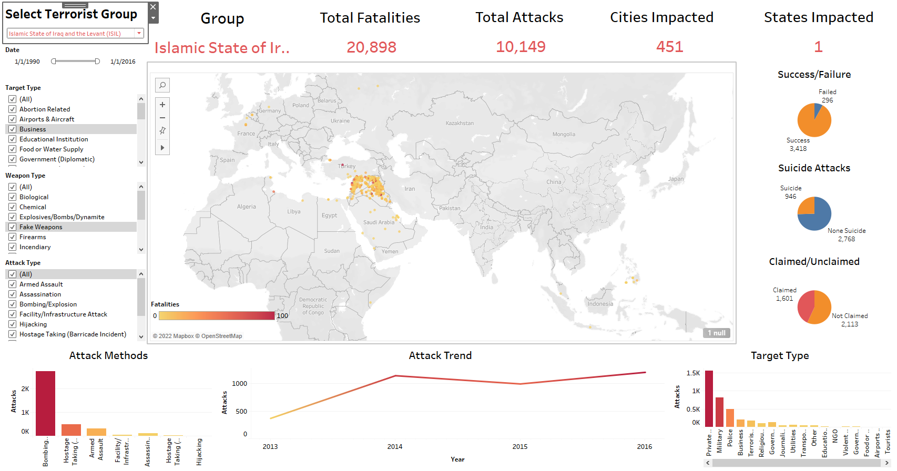

When hovering over ISIL attacks on the map, information based on the exact attack display in the tool tip such as location, motive, summary of the event, and number of fatalities.

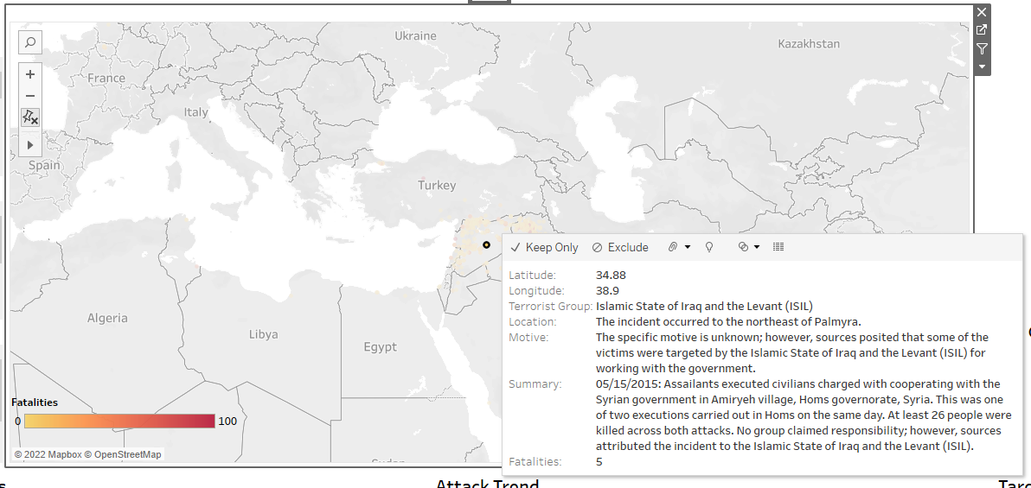

# Conclusion

The Global Terrorism Analysis Dashboard contains two primary dashboards. The Global Terrorism Dashboard contains broad information such as total attacks and fatalities throughout the world. The Target Group Analysis Dashboard contains information based on terrorist group. Both dashboards contain user friendly filters to answer user questions based on overall global terrorism and terrorism by terrorist group.

Thank you for reading my tableau analysis!!!

Regards,

Julia Farson